**Analysis of Retail Sales Data**

**Abstract:**

This document presents a comprehensive analysis of the `PL_RETAIL_DB` database, which is designed to capture retail sales transactions. The study focuses on the structure of the database, data integrity checks, and various SQL queries that facilitate data retrieval and analysis. By utilising these queries, we aim to derive meaningful insights into customer behaviour, sales trends, and product performance within the retail sector.

**Keywords:**

Retail sales, SQL queries, data analysis, customer behaviour, database management.

**1. Introduction:**

The retail industry is a dynamic sector that requires efficient data management and analysis to understand consumer behaviour and optimise sales strategies. The `PL_RETAIL_DB` database serves as a repository for retail sales transactions, capturing essential information such as transaction details, customer demographics, and product categories. This paper outlines the structure of the database and provides SQL queries that can be employed to extract valuable insights from the data.

**2. Database Structure:**

**2.1 Database Creation**:

The `PL_RETAIL_DB` database is created using the following SQL commands:

```sql

CREATE DATABASE PL_RETAIL_DB;

USE PL_RETAIL_DB;

CREATE TABLE retail_sales (

transactions_id INT PRIMARY KEY,

sale_date DATE,

sale_time TIME,

customer_id INT,

gender VARCHAR(10),

age INT,

category VARCHAR(35),

quantity INT,

price_per_unit FLOAT,

cogs FLOAT,

total_sale FLOAT

);

This table captures critical information necessary for analysing retail sales.

**2.2 Data Integrity Checks:**

Data integrity is crucial for accurate analysis. The following checks are implemented:

**2.2.1 Record Count:**

To determine the total number of records in the dataset:

```sql

SELECT COUNT(*) FROM retail_sales;

Output:



**2.2.2 Customer Count:**

To find the number of unique customers:

```sql

SELECT COUNT(DISTINCT customer_id) FROM retail_sales;

Output :



**2.2.3 Category Count:**

To identify all unique product categories:

```sql

SELECT DISTINCT category FROM retail_sales;

Output:

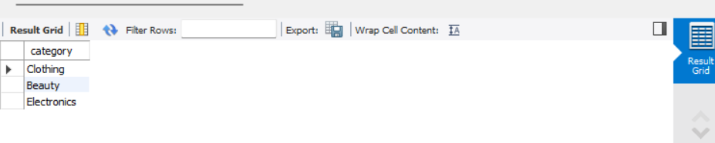

**2.2.4 Null Value Check:**

To check for any null values in the dataset:

```sql

SELECT * FROM retail_sales WHERE

sale_date IS NULL OR

sale_time IS NULL OR

customer_id IS NULL OR

gender IS NULL OR

age IS NULL OR

category IS NULL OR

quantity IS NULL OR

price_per_unit IS NULL OR

cogs IS NULL;

Output:

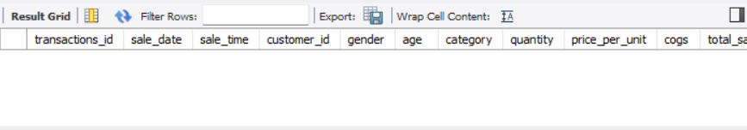

**2.2.5 Deleting Records with Missing Data:**

To maintain data integrity by deleting records with missing values:

```sql

DELETE FROM retail_sales WHERE

sale_date IS NULL OR

sale_time IS NULL OR

customer_id IS NULL OR

gender IS NULL OR

age IS NULL OR

category IS NULL OR

quantity IS NULL OR

price_per_unit IS NULL OR

cogs IS NULL;

Output:

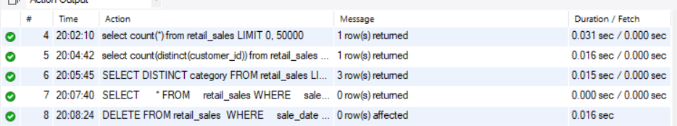

**3. Data Queries:**

**3.1 Sales on Specific Dates:**

To retrieve all columns for sales made on '2022-11-05':

```sql

SELECT * FROM retail_sales WHERE sale_date = '2022-11-05';

Output:

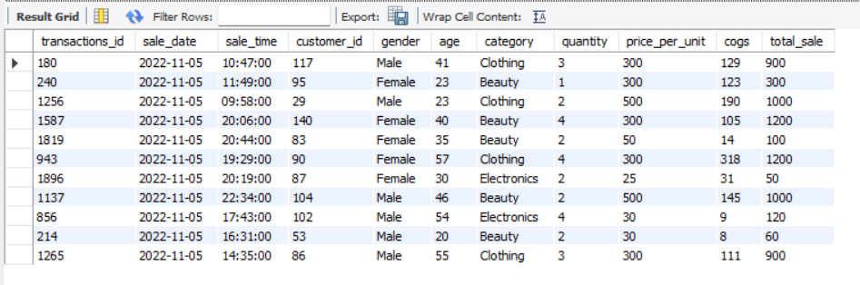

**3.2 Analysis of Clothing Sales:**

To analyze transactions where the category is 'Clothing' and quantity sold exceeds four in November 2022:

```sql

SELECT * FROM retail_sales WHERE

category = 'Clothing' AND

MONTH(sale_date) = 11 AND

YEAR(sale_date) = 2022 AND

quantity >= 4;

Output:

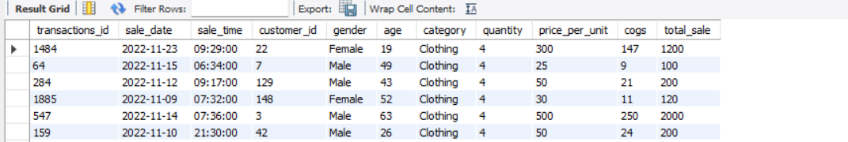

**3.3 Total Sales by Category:**

To calculate total sales for each product category:

```sql

SELECT category, SUM(total_sale) AS net_sale, COUNT(*) AS total_orders

FROM retail_sales GROUP BY category;

Output:

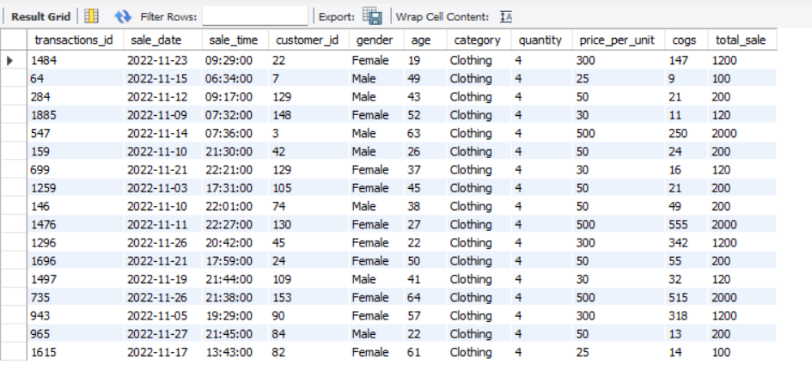

**3.4 Average Age of Customers in Beauty Category:**

To find the average age of customers purchasing items from the 'Beauty' category:

```sql

SELECT ROUND(AVG(age), 2) AS avg_age FROM retail_sales WHERE category = 'Beauty';

Output:



**3.5 High-Value Transactions Analysis:**

To identify all transactions where total sales exceed 1000:

```sql

SELECT * FROM retail_sales WHERE total_sale > 1000;

Output:

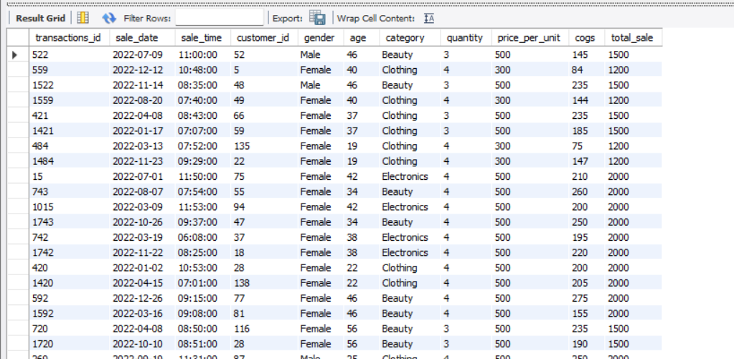

**3.6 Transactions by Gender and Category:**

To analyze transactions made by each gender in different categories:

```sql

SELECT category, gender, COUNT(*) AS total_trans

FROM retail_sales GROUP BY category, gender ORDER BY category;

Output:

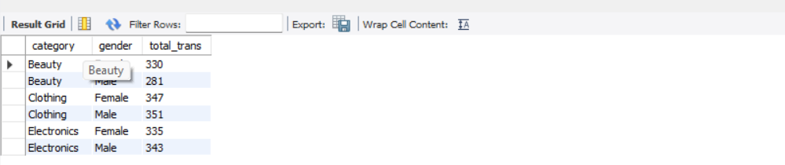

**3.7 Best Selling Month Analysis:**

To calculate average sales per month and identify the best-selling month in each year:

```sql

SELECT year, month, avg_sale FROM (

SELECT EXTRACT(YEAR FROM sale_date) AS year,

EXTRACT(MONTH FROM sale_date) AS month,

AVG(total_sale) AS avg_sale,

RANK() OVER(PARTITION BY EXTRACT(YEAR FROM sale_date) ORDER BY AVG(total_sale) DESC) AS ranks

FROM retail_sales GROUP BY year, month

) AS t1 WHERE ranks = 1;

Output:

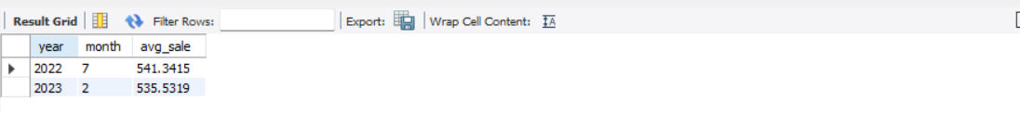

**3.8 Top Customers by Total Sales:**

To find the top five customers based on total sales:

```sql

SELECT customer_id, SUM(total_sale) AS total_sales

FROM retail_sales GROUP BY customer_id ORDER BY total_sales DESC LIMIT 5;

Output:

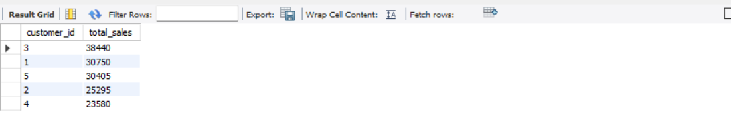

**3.9 Unique Customers per Category Analysis:**

To determine the number of unique customers purchasing items from each category:

```sql

SELECT category, COUNT(DISTINCT customer_id) AS cnt_unique_cs FROM retail_sales GROUP BY category;

Output:

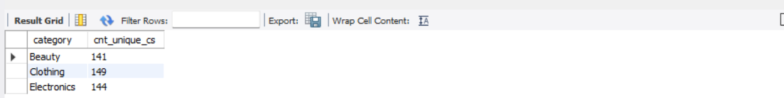

**3.10 Shift Analysis of Orders:**

To categorize orders into shifts (Morning, Afternoon, Evening):

```sql

WITH hourly_sale AS (

SELECT *,

CASE

WHEN EXTRACT(HOUR FROM sale_time) < 12 THEN 'Morning'

WHEN EXTRACT(HOUR FROM sale_time) BETWEEN 12 AND 17 THEN 'Afternoon'

ELSE 'Evening'

END AS shift

FROM retail_sales)

SELECT shift, COUNT(*) AS total_orders FROM hourly_sale GROUP BY shift;

Output:

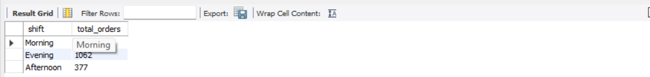

**4. Conclusion:**

The `PL_RETAIL_DB` database provides a robust framework for analyzing retail sales data. Through various SQL queries outlined in this paper, stakeholders can extract valuable insights regarding customer behaviour, sales performance across different categories, and overall market trends. Future work may involve enhancing data collection methods or integrating advanced analytics techniques to further optimize decision-making processes within the retail sector.